Getting to the Sheraton Grand Hotel and Spa

Driving
- From East
Follow the A1 West into Edinburgh and follow the signs to the city centre. The hotel is located just of the west end of Princes Street on the West Approach Road just before the EICC.
- From North
Take the M90 from the North of Scotland, which passes through Perth. Cross the Forth Road Bridge into Edinburgh city centre and the hotel is located off the West Approach Road.
- From West
Take the M8 Motorway from Glasgow, which joins the A71, to the city centre. The hotel is located on the West Approach Road just after the EICC.
- From South
Take the M6 North onto the A74, which follows onto the A702 which will take you to the city centre. The hotel is located just off the west end of Princes Street on West Approach Road.
- From Airport
Follow the A8 to the city center; pass the Haymarket train station head towards Princes Street, just before Princes Street turn to your right up Lothian Road.
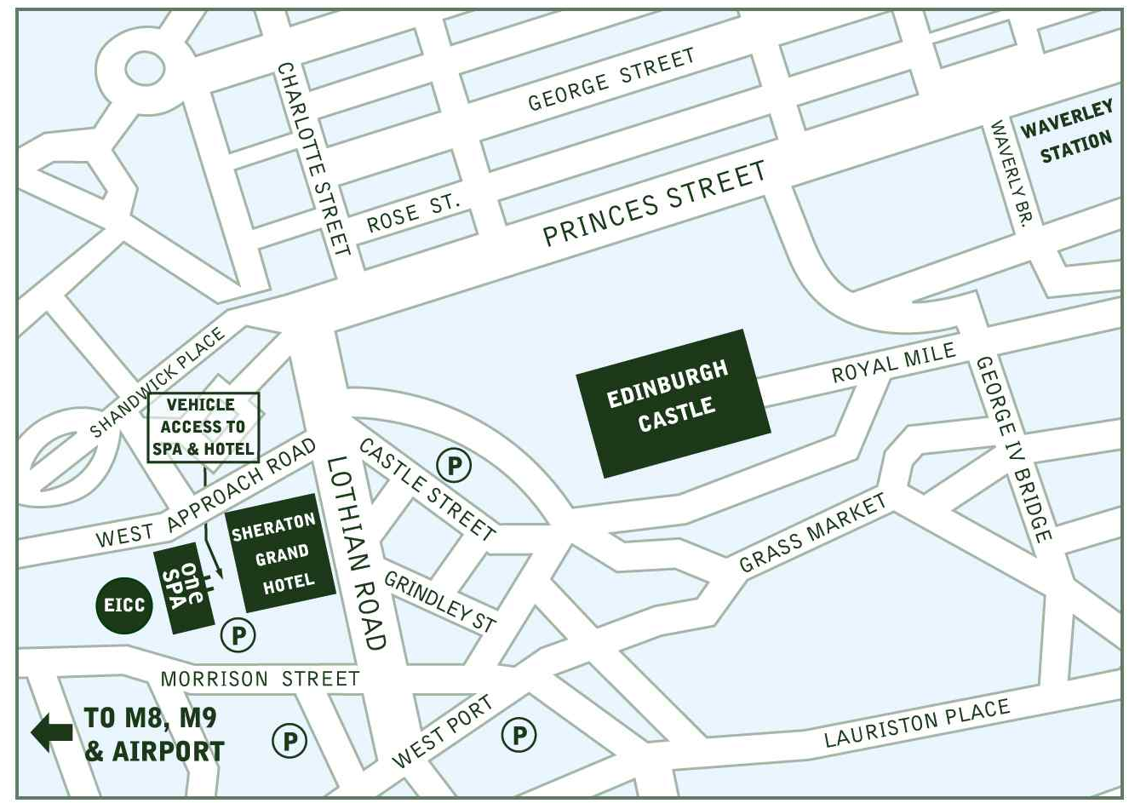
At the second set of lights turn right onto the West Approach Road, at the first set of lights turn left and this brings you into the Hotel forecourt.

By Train
There are two train stations in Edinburgh. Haymarket is closest station to the hotel and handles trains going to/from places N0rth & West of Edinburgh (Stirling, Aberdeen, Inverness, St Andrews, Glasgow). Waverly Station handles ALL trains that travel through Edinburgh. It is possible to get a taxi from outside both stations.

Car Parking Facilities
We have 119 spaces located at the rear entrance of the hotel, accessed from the West Approach Road. Use of the car parking facilities is charged at the following rates:
0 – 2 Hours - £3.00
2 – 3 Hours - £4.00
3 – 4 Hours - £5.00
4 – 6 Hours - £7.00
6 – 8 Hours - £9.00
8 – 24 Hours - £18.00

**Discounted Hotel Residents parking - £9.00 (up to 24 hours) – it is not within the hotels policy to reserve car parking spaces.

Access – Height restriction – 2.5 metres

