

October 2017

Dear Colleague,

APSE Renewables & Energy Efficiency Advisory Group

I am writing to inform you that the next meeting of the Scottish Renewables & Energy Efficiency advisory group will be held as follows: - Tuesday 7th November at Volunteer Scotland, Jubilee House, Stirling.

Date: Tuesday 7th November 2017
Time:
10:00 Tea & coffee on arrival
10:30 Advisory Group meeting starts
12:30 Lunch
13:30 Meeting close

Venue: Volunteer Scotland, Jubilee House, Forthside Way, Stirling. FK8 1QZ

Map: Click here

The agenda for the meeting and previous minutes are enclosed.

This is a FREE event for all members and officers of councils in APSE membership.

Please ensure you confirm your attendance either by telephoning Lyndsey Moffat on 01698 459 051; or click here to book online; by email to Lmoffat@apse.org.uk or by faxing the attached form to 01698 200 316 in order that the necessary arrangements can be made.

Yours faithfully,

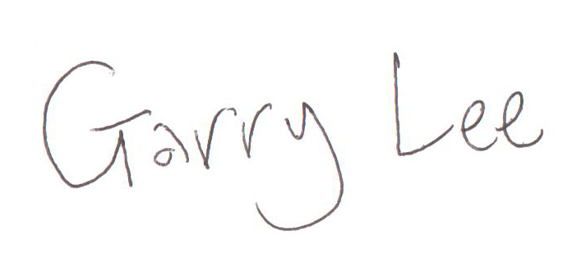

Garry Lee
Acting Principal Advisor
Association for Public Service Excellence


Association for Public Service Excellence
Brandon House Business Centre
Units 18-20, 23-25 Brandon Street
Hamilton ML3 6DA
telephone: 01698 459 051
fax: 01698 200 316
email: enquiries@apse.org.uk
web:www.apse.org.uk


Fax back attendance form

APSE Renewables & Energy Efficiency Advisory Group

Tuesday 7th November at Volunteer Scotland, Jubilee House, Forthside Way, Stirling. FK8 1QZ

Please complete this form and return it to APSE as soon as possible via fax to Lyndsey Moffat, on 01698 200 316.

Authority:………………………...……………………………………………………………………

Address:………………………....……………………………………………………………………..

……………………………………………………….……………………….………………………...

Post Code……………………
Name | Email | To attend Advisory Group | Apologies for Advisory Group
 |  |  | 
 |  |  | 
 |  |  | 
 |  |  | 
Please help us keep our records up-to date

Persons contact details have changed, please amend as indicated
Please add name and details to your database
Person has left the company (if so please complete the details below for the replacement)

Please print details

Title First Name Surname
Job Title Authority
Department
Address
Post Code _______
Telephone Fax Email

this form and return via fax to: 0161 772 1811


Renewables & Energy Efficiency advisory group

Tuesday 7th November at Volunteer Scotland, Jubilee House, Forthside Way, Stirling. FK8 1QZ

- Introduction & Welcome

- Attendance & Apologies

- Minutes of previous meeting – 13th September 2017

- Matters arising

- Highland Council - Heat Mapping
Speaker: Jackie Sayer/Eddie Boyd, Highland Council.

- Fintry Development Trust - Renewable Energy projects
Speakers: Matthew Black, Community Project Manager, Fintry Development Trust

- Callander Community Development Trust - Community Hydro Scheme
Speaker: Frank Park, Callander Community Hydro Ltd. Chair (invited)

- APSE Update
- National Issues
- Briefings/ research
Speaker: Garry Lee, Acting Principal Advisor (Scotland), APSE

- A.O.C.B.

- Date and time of next meeting – 24th April, 2018 - Venue TBC

- Lunch

